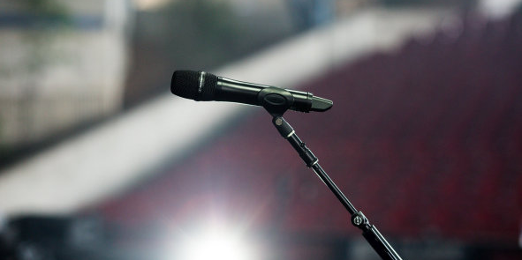 | 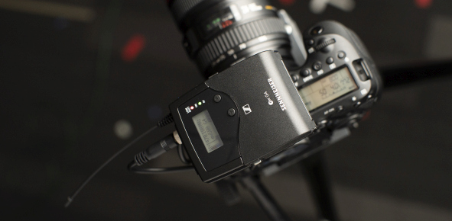

Go wireless with Sennheiser’s anniversary special offers

Professional sound quality, UHF reliability and freedom of movement for musicians, presenters and videographers

Marlow, UK, November 10, 2020 – Sennheiser’s special 75th anniversary deals continue throughout the months of November and December, with many of the audio specialist’s most popular rack-mount and portable RF wireless systems from the evolution wireless and XSW ranges all available with 100 EUR/USD off. Whether you are a musician, presenter or audio for video enthusiast – Sennheiser has great offers in store for all types of wireless applications in the professional UHF band.
Please visit www.sennheiser.com/special-deals for a list of participating dealers. All prices given are MSRP (EUR) or MAP (USD), respectively.

Handheld mics for vocalists and presenters
The evolution wireless 100 G4 systems have been engineered for professional live sound. Choose between Sennheiser’s popular e 835 (dynamic, cardioid), e 845 (dynamic, super-cardioid), e 865 (condenser, super-cardioid), e 935 (dynamic, cardioid) and e 945 (dynamic, super-cardioid) capsules coupled with a rugged transmitter featuring an integrated mute switch. Mic clamp and batteries included. The associated full-metal rack-mount receiver with intuitive LCD display comes complete with two rod antennas, rack-mount set, and RJ 10 cable.

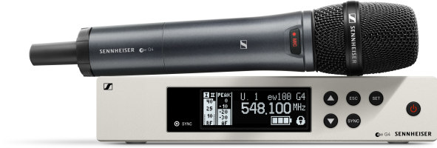 | The ew 100 G4 Vocal Set is available with a wide choice of popular mic capsules

The ew 100 G4 systems feature a fast frequency allocation function for up to 12 receivers, IR synchronization, up to 20 compatible channels and a switching bandwidth of up to 42 MHz with 1680 tunable frequencies. The range of up to 100 m (300 ft) leaves plenty of headroom for any application.

Anniversary pricing:
ew 100 G4-835-S: EUR/USD 499 (instead of 599)
ew 100 G4-845-S: EUR/USD 549 (instead of 649)
ew 100 G4-865-S: EUR/USD 649 (instead of 749)
ew 100 G4-935-S: EUR/USD 549 (instead of 649)
ew 100 G4-945-S: EUR/USD 599 (instead of 699)

Also available is the XSW 2-835 Vocal Set, an easy to use, all-in-one UHF wireless system for singers and presenters featuring Sennheiser’s evolution 835 cardioid microphone capsule. The system has a tuning bandwidth of up to 24 MHz, up to 12 compatible frequencies per range, true diversity antenna switching for enhanced signal reception and automatic frequency management. The all-metal receiver comes complete with a rack-mount kit.

Anniversary pricing:
XSW 1-835 Vocal Set: EUR 339 (instead of 439) / USD 299.95 (instead of 399.95)

The XSW 1-835 Vocal Set is on special offer throughout the months of November and December | 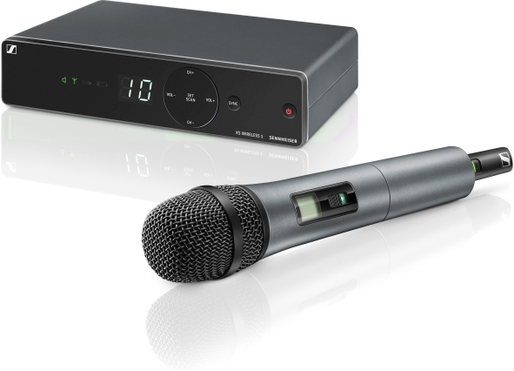

For guitarists & bassists
The ew 100 G4 CI1 is a rugged wireless system for guitarists and bassists, complete with rack-mount receiver, instrument transmitter, Ci1 instrument cable and accessories such as rack-mount kit, antennas, batteries, RJ 10 linking cable and power supply unit.

Anniversary pricing:
ew 100 G4-CI1: EUR/USD 449 (instead of 549)

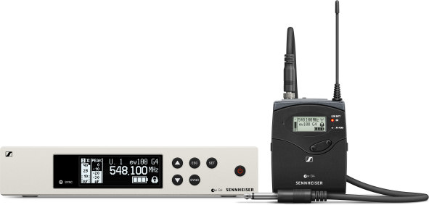 | Wireless freedom for the guitar and bass: the ew 100 G4-CI1

Systems with a lavalier or headworn mic
Sometimes it has to be a hands-free solution – especially when you’re presenting but also when you’re playing an instrument while singing at the same time or even when miking up instruments. The evolution wireless systems come complete with all accessories and offer lavalier mics (ME 2 – omni-directional, ME 4 – cardioid), a headworn mic (ME 3 – cardioid) or a combo set, which includes both a handheld and a bodypack transmitter with lavalier mic.

Anniversary pricing:
ew 100 G4-ME2: EUR/USD 499 (instead of 599)
ew 100 G4-ME3: EUR/USD 549 (instead of 549)
ew 100 G4-ME4: EUR/USD 499 (instead of 599)
ew 100 G4-ME2/835-S: EUR/USD 899 (instead of 999)

Bestsellers for audio for video enthusiasts and filmmakers
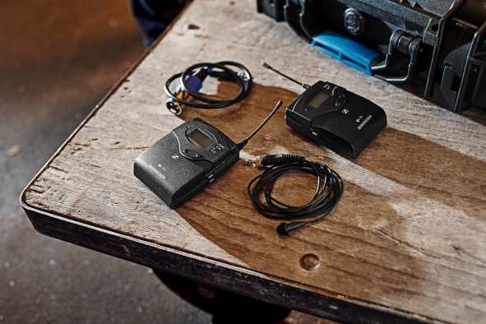 | The evolution wireless camera sets are a firm favorite with mobile journalists

The evolution wireless camera systems include everything you need for professional film and interview sound. On special offer are the ew 112P G4 with omni-directional ME 2 lavalier mic, ew 122P G4 with ME 4 cardioid lavalier mic, ew 135P G4 with handheld microphone transmitter and ew 100 ENG G4, a multi-purpose set for mobile journalism and documentaries with an ME 2 lav mic and a plug-on transmitter for dynamic microphones.

Anniversary pricing:
ew 112P G4: EUR 499 (instead of 599) / USD 499 (instead of 599.95)
ew 122P G4: EUR/USD 499 (instead of 599)
ew 135P G4: EUR/USD 499 (instead of 599)
ew 100 ENG G4: EUR/USD 699 (instead of 799)

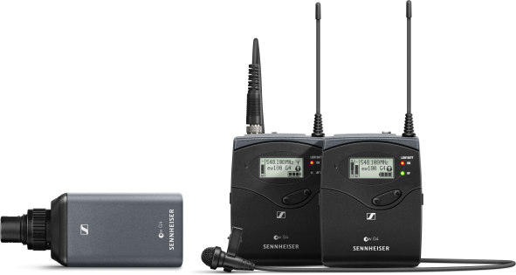 | The ew 100 ENG G4 set

The images accompanying this press release can be downloaded at https://sennheiser-brandzone.com/c/181/CCAgF7Er.

About Sennheiser
Founded in 1945, Sennheiser is celebrating its 75th anniversary this year. Shaping the future of audio and creating unique sound experiences for customers – this aim unites Sennheiser employees and partners worldwide. The independent family company, which is managed in the third generation by Dr. Andreas Sennheiser and Daniel Sennheiser, is today one of the world’s leading manufacturers of headphones, loudspeakers, microphones and wireless transmission systems. In 2019, the Sennheiser Group generated turnover totaling €756.7 million.
www.sennheiser.com

Global Press Contact

Stephanie Schmidt
Stephanie.schmidt@sennheiser.com
+49 (5130) 600 – 1275

